

**RETAIL MANAGEMENT APPLICATION**

**USING SALESFORCE**

**Category: Salesforce Associate**

**Team ID : NM2023TMID36571. Team SmartBridge,.**

**RETAIL MANAGEMENT APPLICATION USING SALESFORCE**

Retailing encompasses the business activities involved in selling goods and services to Consumers for their personal, family, or household etc. A CRM product owner has requested to Create two applications, one is a sales app for sales reps to use this application and store Customers data, and the second application is a service app for service reps/agents to provide Support to customers in dealing cases. To generate business on top of the customers.

**1.Introduction**

Are you new to Salesforce? Not sure exactly what it is, or how to use it? Don’t know where You should start on your learning journey? If you’ve answered yes to any of these questions, Then you’re in the right place. This module is for you.

Welcome to Salesforce! Salesforce is game-changing technology, with a host of Productivity-boosting features, that will help you sell smarter and faster. As you work toward Your badge for this module, we’ll take you through these features and answer the question, “What is Salesforce, anyway?

**1.overview**

Salesforce is a cloud-based Customer Relationship Management (CRM) platform that enables businesses to manage customer data, sales operations, and marketing campaigns..

**2.Purpose**

Salesforce can be used to manage orders from retail stores and distributors, including tracking orders, processing payments, and managing inventory levels. This can help field sales teams ensure that orders are fulfilled quickly and accurately and that inventory levels are maintained at optimal levels.

**What Is Salesforce?**

Salesforce is your customer success platform, designed to help you sell, service, market,Analyze, and connect with your customers.

Salesforce has everything you need to run your business from anywhere. Using standard Products and features, you can manage relationships with prospects and customers,Collaborate and engage with employees and partners, and store your data securely in the Cloud. So what does that really mean? Well, before Salesforce, your contacts, emails, follow up Tasks, and prospective deals might have been organized something like this

**2.Problem Definition & Design Thinking**

**1.Empathy Map**

An empathy map is a collaborative tool teams can use to gain a deeper insight into their customers. Much like a user persona, an empathy map can represent a group of users, such as a customer segment. The empathy map was originally created by Dave Gray and has gained much popularity within the agile community.

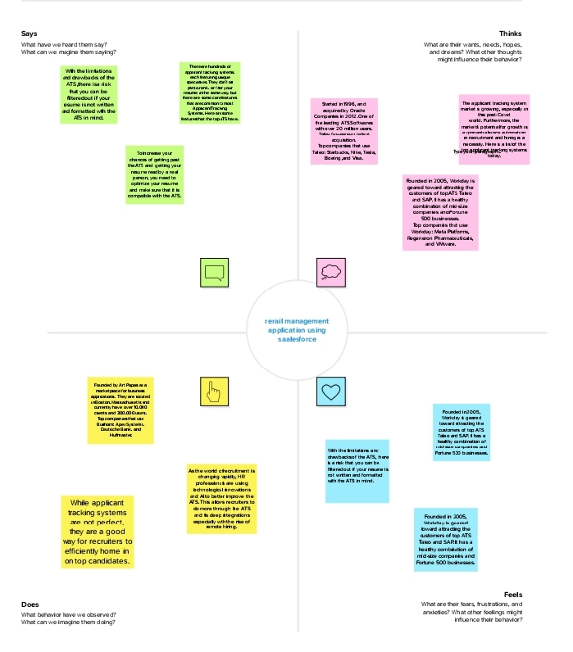 An empathy map is a widely used visualization tool. The primal purpose of an empathy map is to bridge the understanding of the end user. Within context of its application, this tool is used to build a shared understanding of the user’s needs and provide context to a user centered solution. The traditional empathy map begins with four categories they are says, thinks,does and feels.

* Says category contains what the user says out loud during research.
* Thinks category contains what the user is thinking
* Does category contains the user’s action and behavior.

•Feels category contains the user’s emotional state in context with their experience.

**2. Ideation & Brainstorming Map**

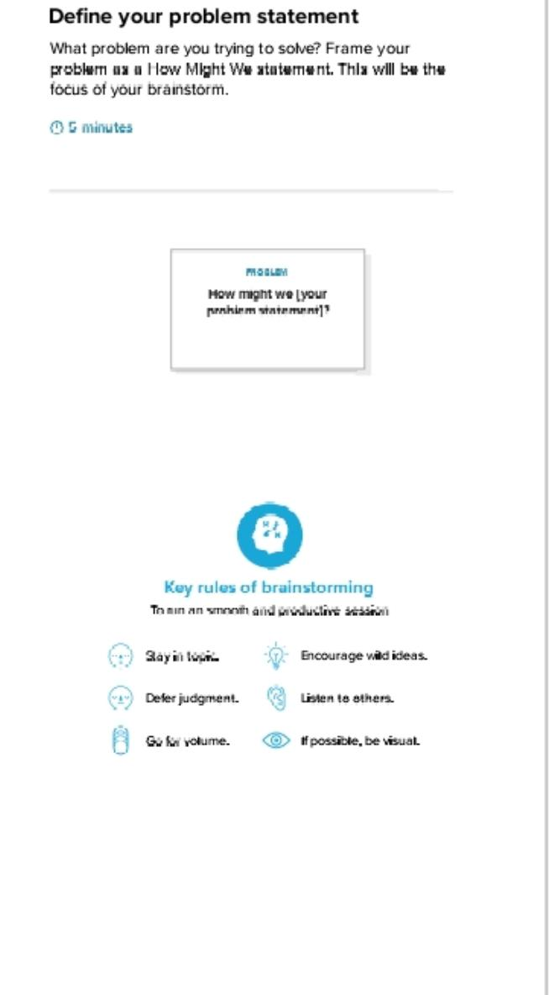 Brainstorming is an activity that will help you generate more innovative ideas. Its one of many methods of ideations. The process of coming up with new ideas and its core to the design thinking process. It is a process of forming ideas from conception to implementation, most often in a business setting. It is expressed via graphical, written or verbal methods and arises from past or present knowledge, influences, opinions, experiences and personal convictions. There are four types of brainstorming. They are reverse brainstorming, Stops-and-Go brainstorming, Phillips 66 brainstorming, brain writing.

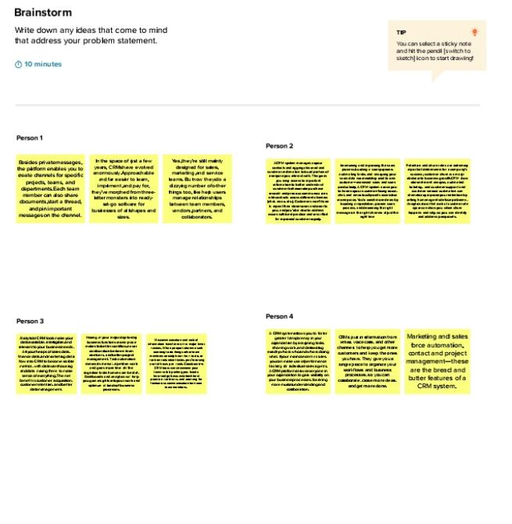

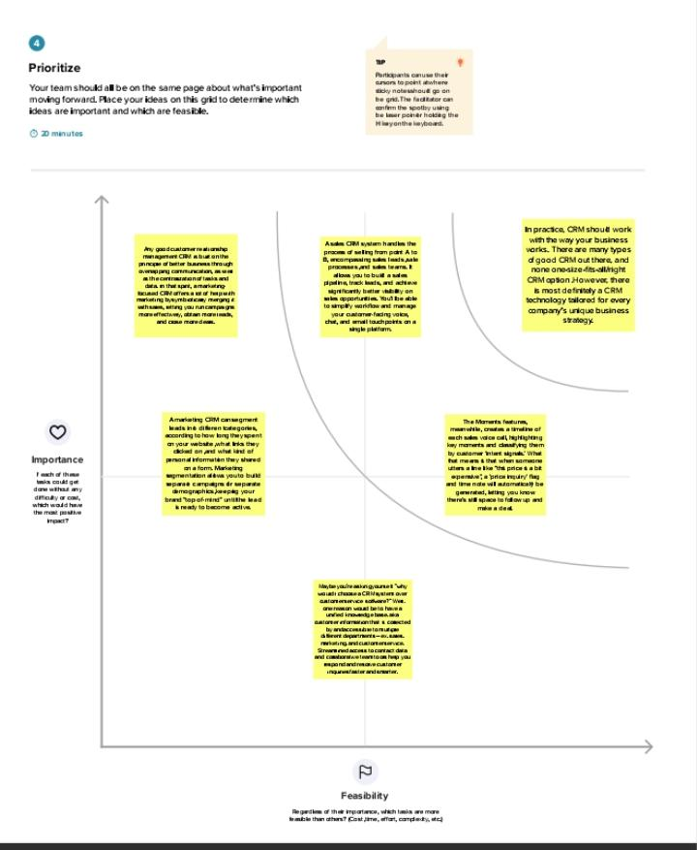

**3.RESULT**

**3.1 Data Model:**

|  |  |
| --- | --- |
| **Object name** | **Fields and relationship** |
| Dispatch/Tracking ( Custom objects) | Field label :Display/tracking  Data type: Text |
| Dispatch/tracking | Field label: Dispatched  Data type: Checkbox |
| Dispatch/tracking | Field label: Dispatch/tracking  Data type: Master detail relationship |

**3.2 Activity & Screenshot**

**Retail management application using Salesforce**

A CRM product owner has requested to create two applications, one is a sales app for sales reps to use this application and store customers data, and the second application is a service app for service reps/agents to provide support to customers in dealing cases. To generate business on top of the customers.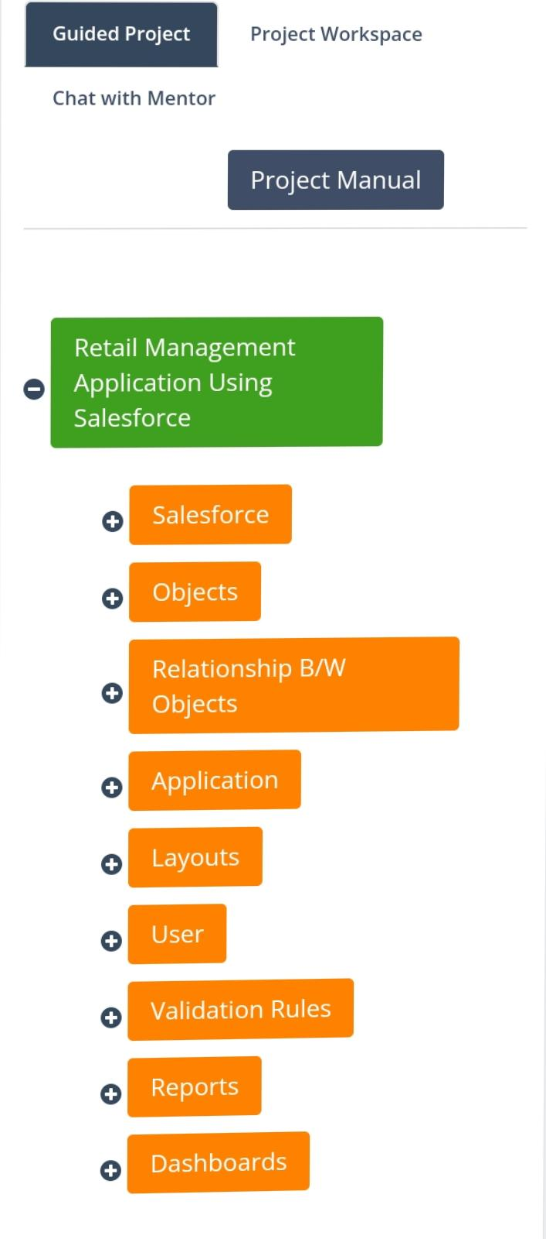

**1.salesforce**

1.1.Creating Developer Account

Creating a developer org in salesforce.

1.Go to developers.salesforce.com/

2.Click on sign up.

3.On the sign up form, enter the following details :

1.First name & Last name

2.Email

3.Role : Developer

4.Company : College Name

5.County : India

6.Postal Code : pin code

7.Username : should be a combination of your name and company

This need not be an actual email id, you can give anything in the Format :[username@organization.com](mailto:username@organization.com)

Click on sign up after filling these.

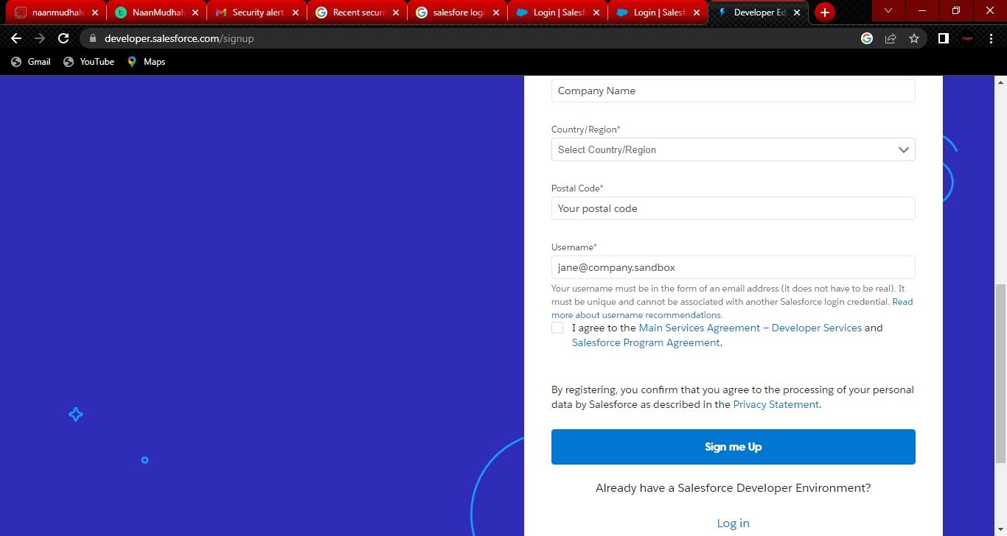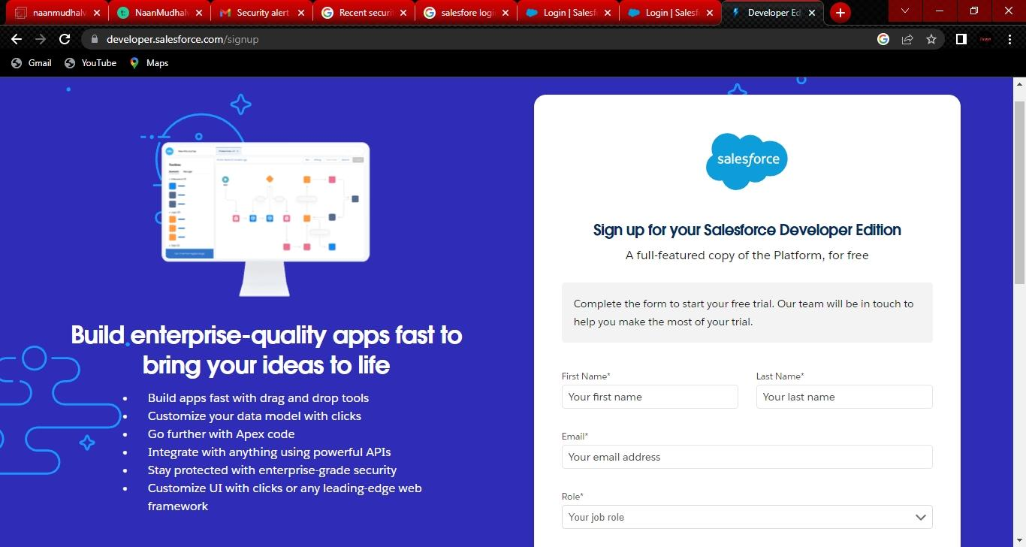

**Account Activation**

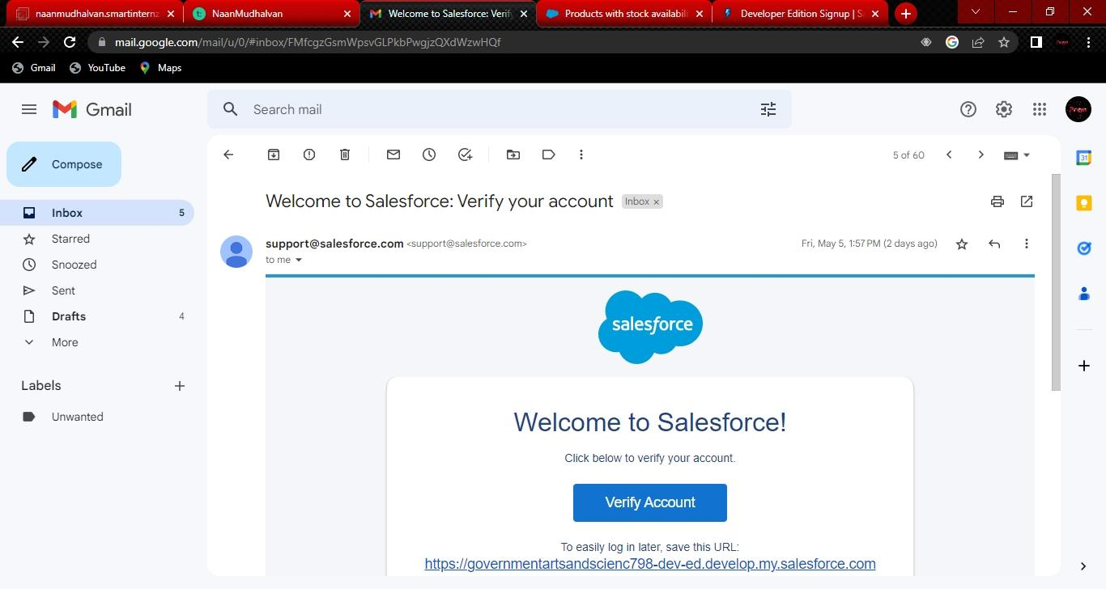 Go to the inbox of the email that you used while signing up. Click on the verify account to Activate your account. The email may take 5-10mins, as

**Login To Your Salesforce Account**

1.Go to salesforce.com and click on login.

2.Enter the username and password that you just created.

3.After login this is the home page which you will see

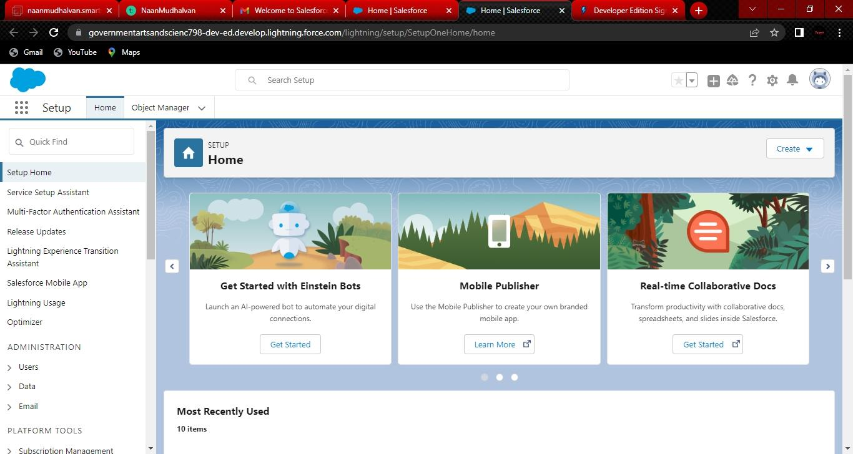

**Salesforce Login**

Htttps://login.salesforce.com

**Milestone-2 Objects:**

Objects are database tables that permit you to store data that is specific to an

Organization.Salesforce objects are of two types:

1) Standard object,

2) Custom objects

Objects involved in retail management are

|  |  |  |
| --- | --- | --- |
| **Application** | **Object** | **Description** |
| Sales app | Campaign | We do promotions by using this object |
| Sales app | Leads | We capture leads here |
| Sales app | Accounts | We capture customers data |
| Sales app | contacts | Employees data of customer |
| Sales app | opportunities | SMB sales orders data |
| Sales app | product | Here we store product details i.e electronic types |
| Sales app | Warehouse | We capture stocks data |
| Sales app | Sales order | This is an actual order which has invoice details |
| Sales app | Dispatch/Tracking | Orders dispatch related info will be stored here |

|  |  |  |
| --- | --- | --- |
| **Application** | **Object** | **Description** |
| Service app | Cases | Historical problems of customers will be stored here |
| Service app | Accounts | We captures customers data |

**Activity-1**

**Creation of object Dispatch/Tracking**

1. 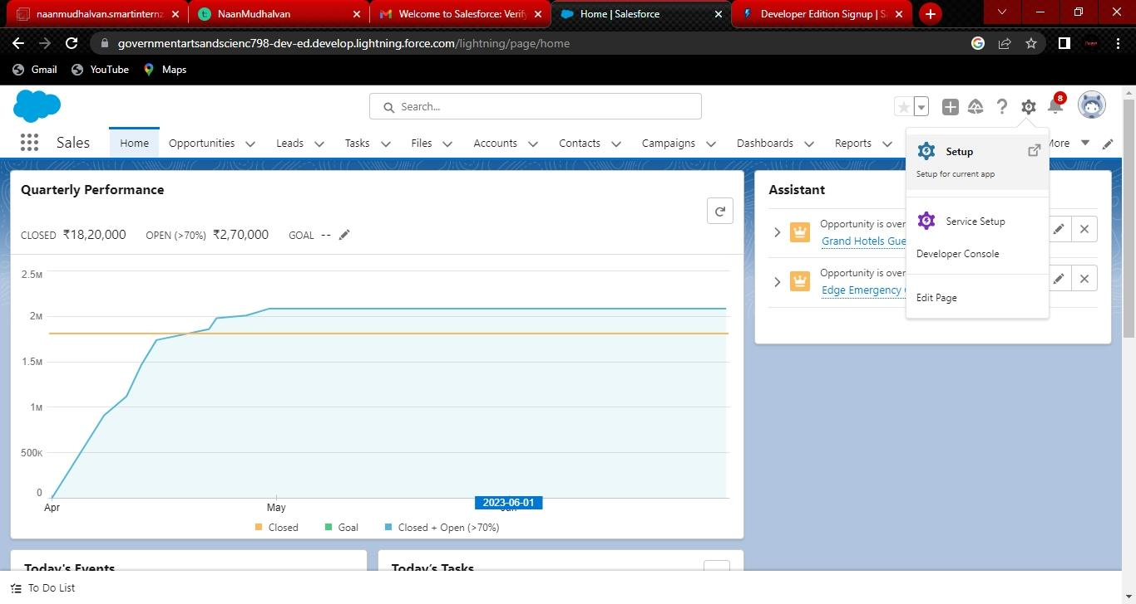Navigate to setup and select object manager.
2. 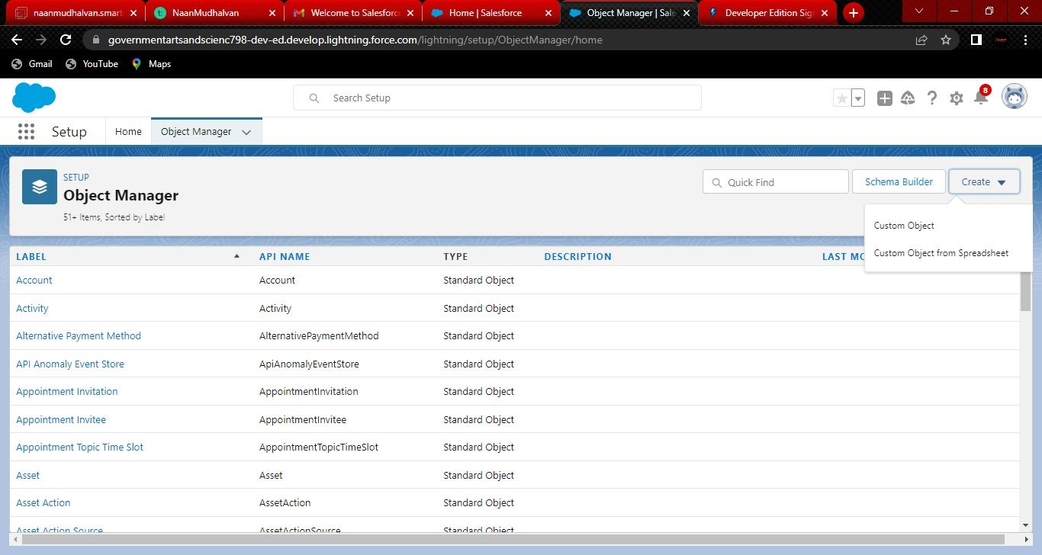At the top of the right side there you can find create custom object.
3. You will navigate to custom object definition edit where you have to give the object name.
4. 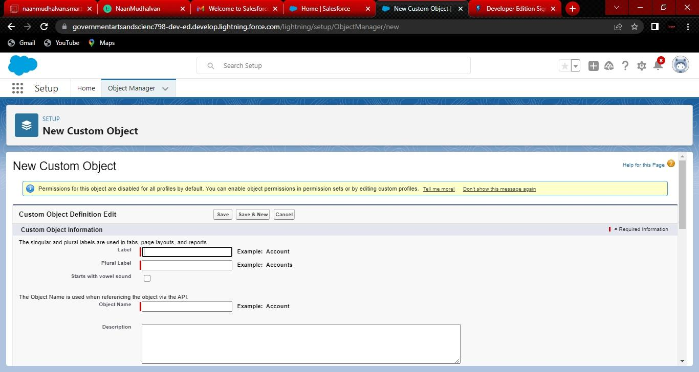The label name has Display/tracking and Plural label has Display/trackings.
5. In enter record name label and format enter name record name has Tracking ID.
6. And the data type has text.
7. In deployment status select deployed option.

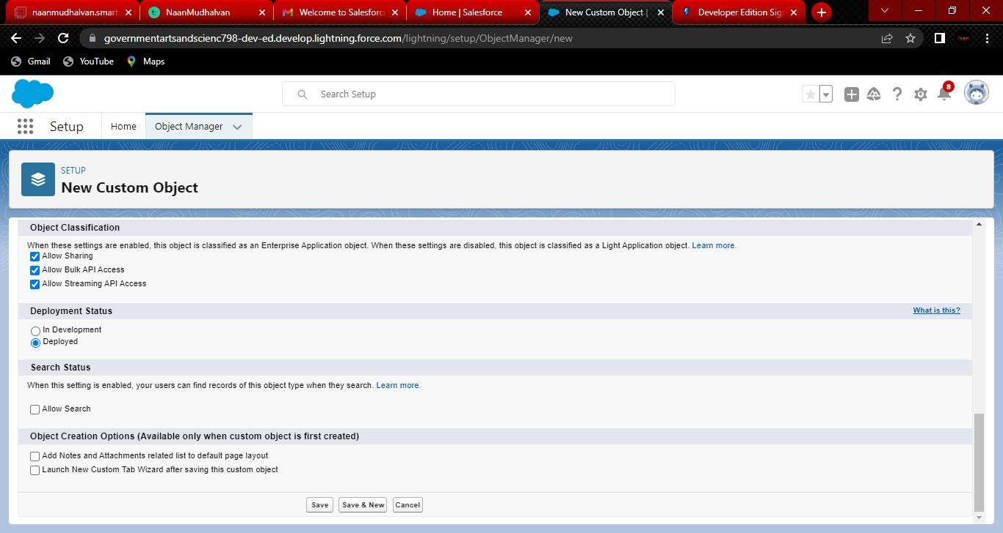

8 ) Ensure that you have to select at least one option in the object creation option; it is

Available only once when a custom object is created.

9 )Then click on next you will navigate to the new custom object tab where you have to

Select tab style and click on next. 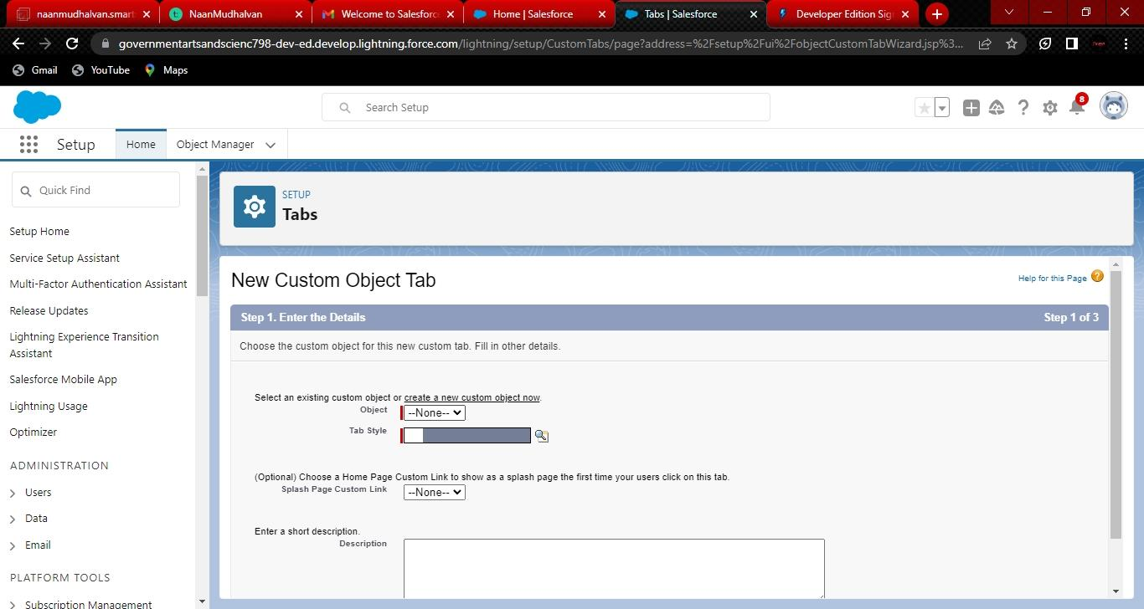

10) After tab selection you will be navigated to add to profiles select default on click on next.

11) Thereafter you have to select a custom app select include tab so that object will be

Available in all objects and select save option.

**Activity-2 Fields available on Dispatch/tracking**

1)Dispatched

2) Expected date of delivery

3) Tracking ID

4) Sales order

**Creation of fields on Dispatch/tracking**

1. Select your object from object selection has Dispatch/Tra2) And select the option fields and relationships.
2. 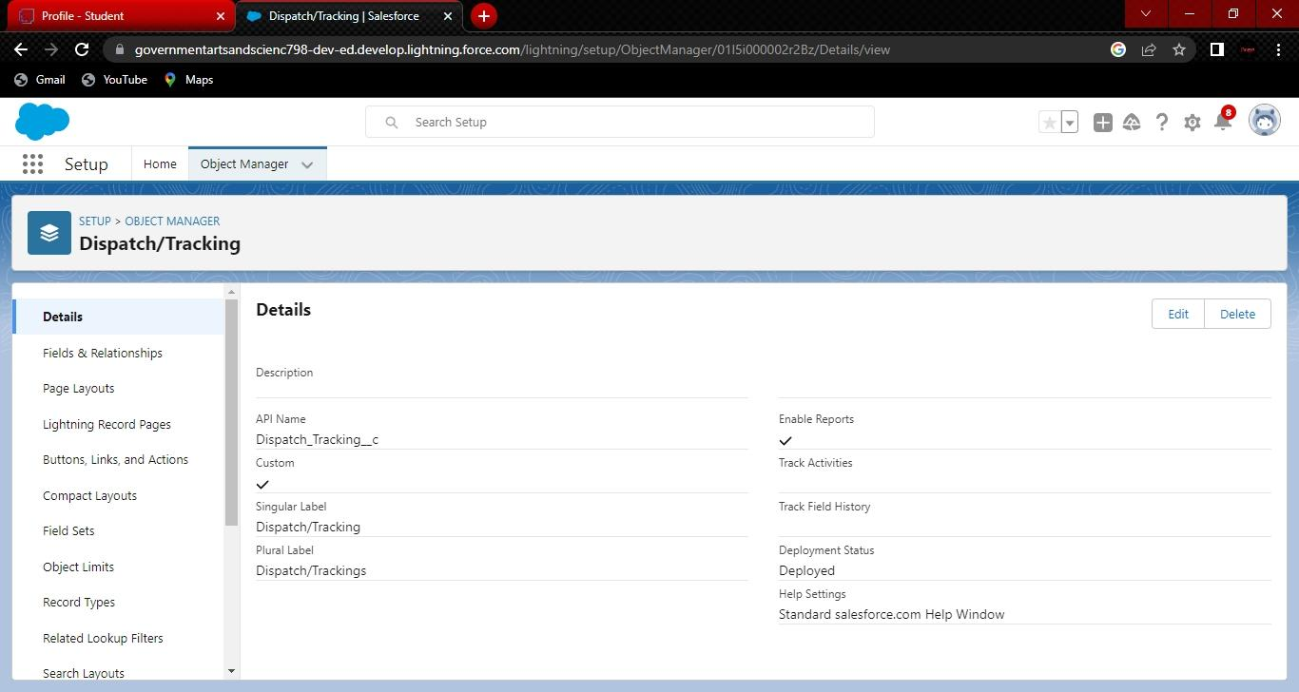And select the option fields and relationships.
3. At the top right side you can find a new select that option
4. Now you have to select data type, Checkbox Has data type.
5. And you will navigate to enter the details page where you give the field label.
6. And give the label name has Dispatched
7. At the bottom of the object you can find options like required,unique, external id select Required option so that always require a value in this field in order to save.
8. Click next you will navigate to field level security click on visible checkbox so that it is Visible to all profiles.

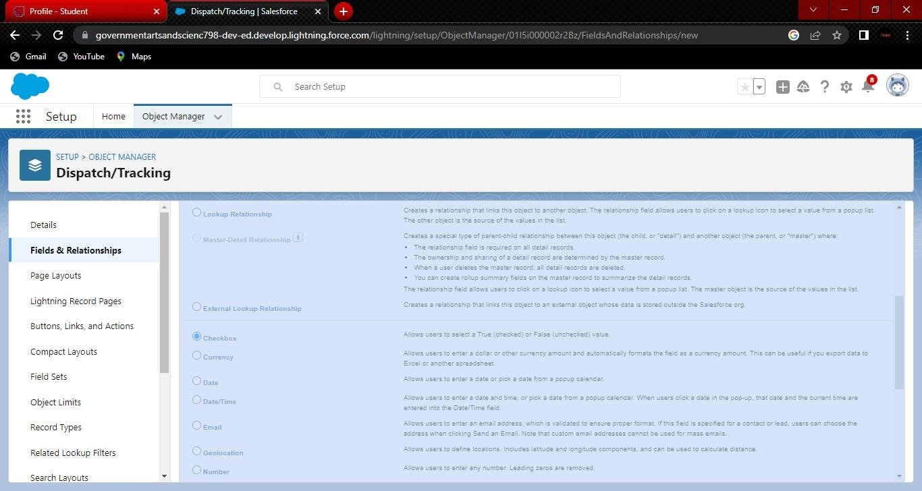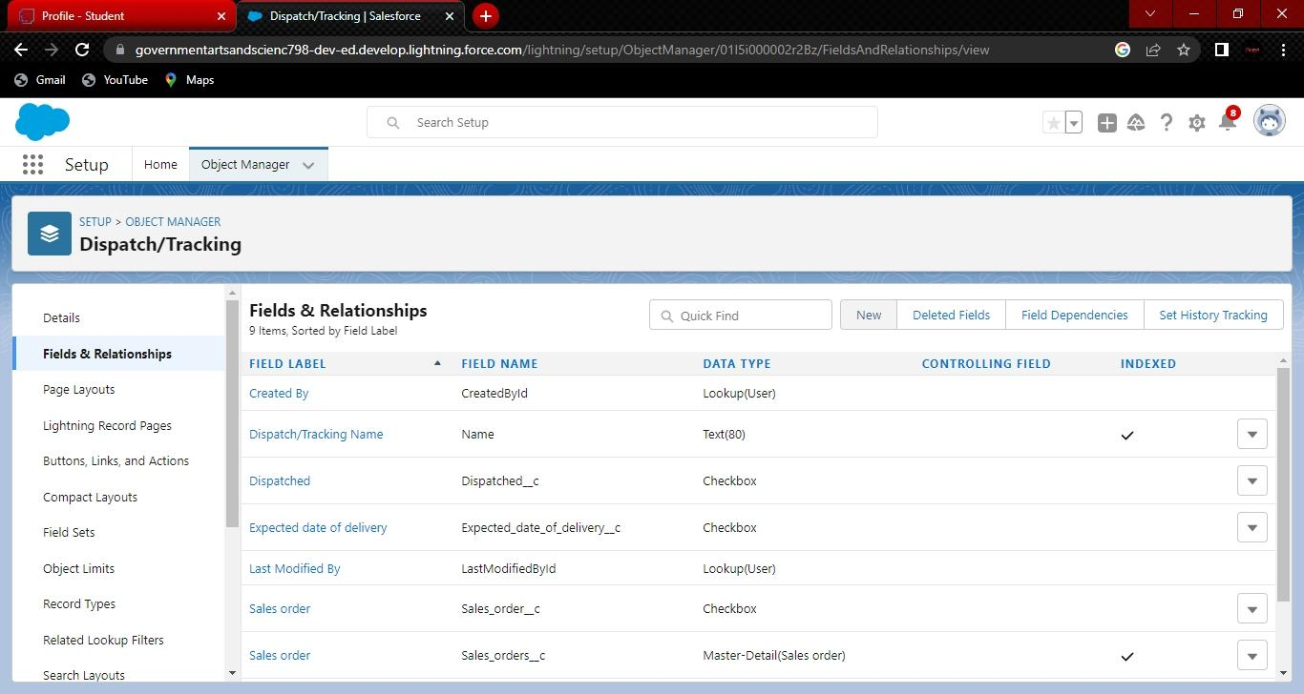

1. 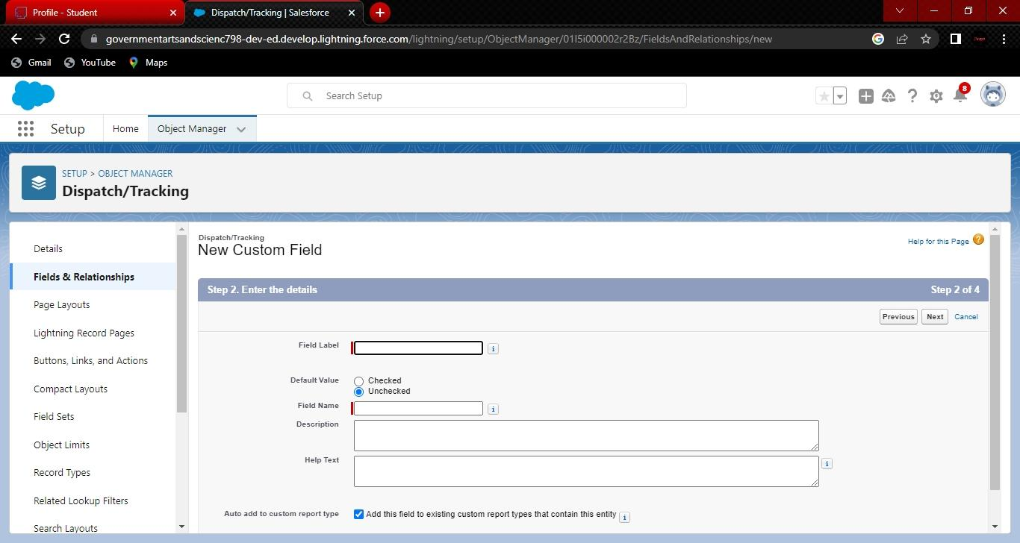Select the next option, select the page layout 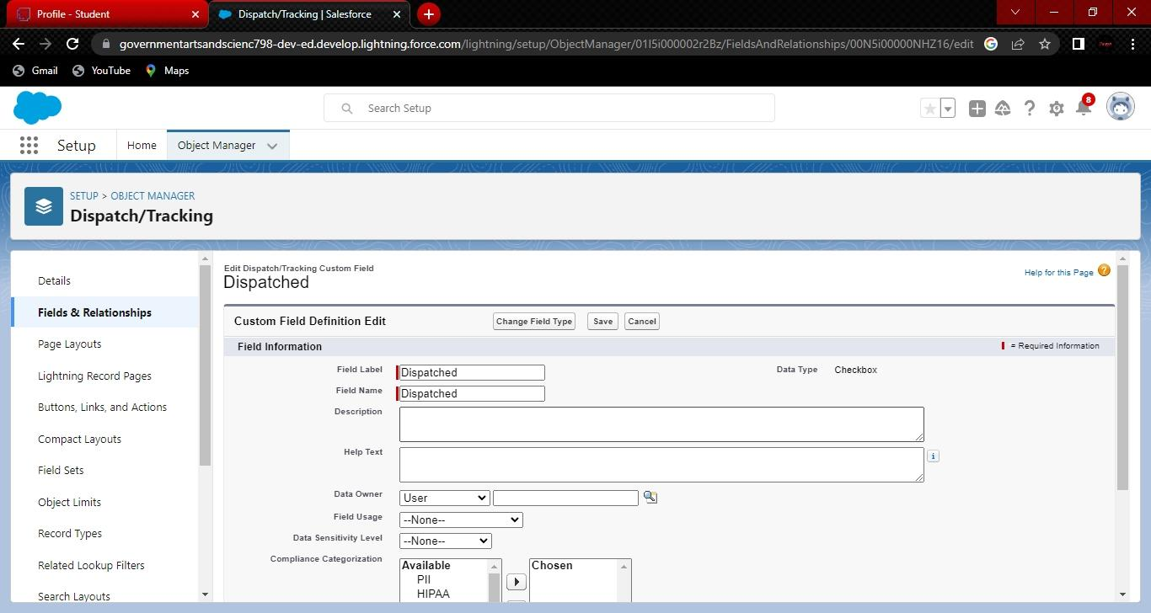and save it.

**Milestone-3 Relationship b/w objects:**

It’s time to take things to the next level with object relationships. Object relationships are special Field types that connect two objects. As a crm product owner create relationships to link objects With each other, so that when users view records, they can also see related data.

**Activity-1:**

**Creation of relationships between objects**

To create a Master Detail relationship between Dispatch/tracking and sales order.

1. Go to the Set Up option from the Home Page and click on it.

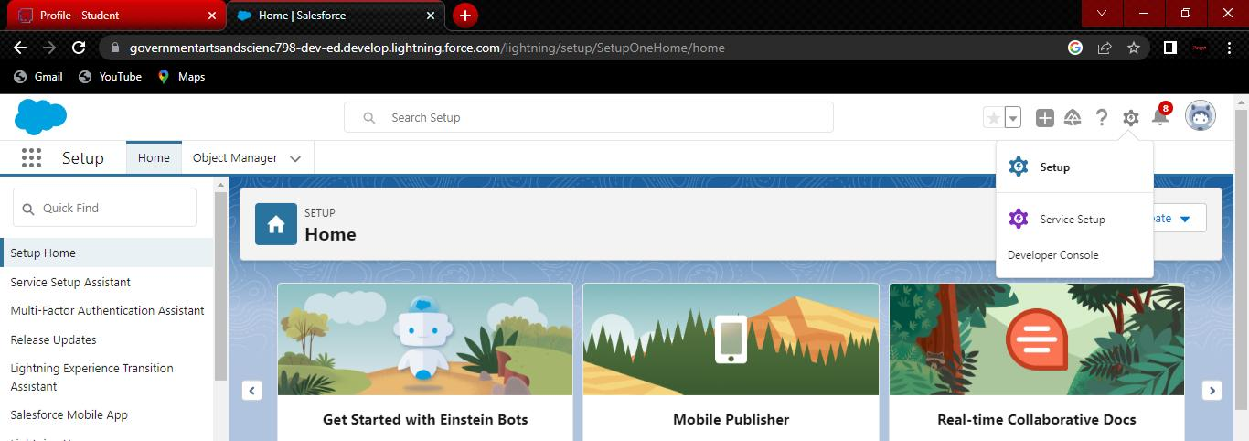

1. Go to the object manager and select ‘Dispatch/tracking’ object from the list
2. And select fields and relationships and click on new.
3. Select the data type has Master detail relationship

5) And select related to the object has sales order, and click on next.

6)You will navigaten to the label name page where you give the label name for the field, give It has sales order and click next.

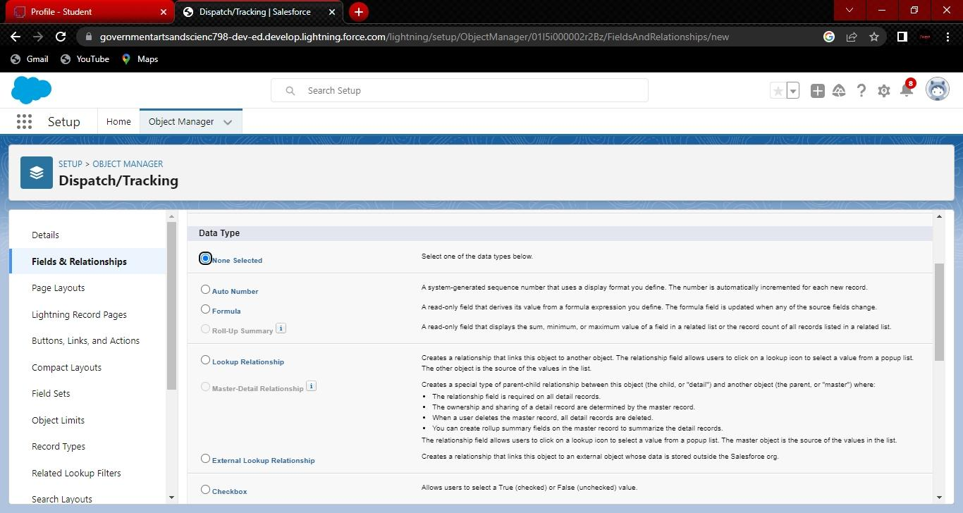

1. Select visible for all profiles in field level security and select page layout in next page and

Save it.

**Milestone-4 Application:**

Apps in Salesforce are a group of tabs that help the application function by working together as a unit. It Has a name, a logo, and a particular An app is a collection of items that work together to serve a Particular function. Salesforce apps come in two flavors: Classic and Lightning.

**Activity-1**

**Creation of Application**

1. Navigate to setup and search for app manager

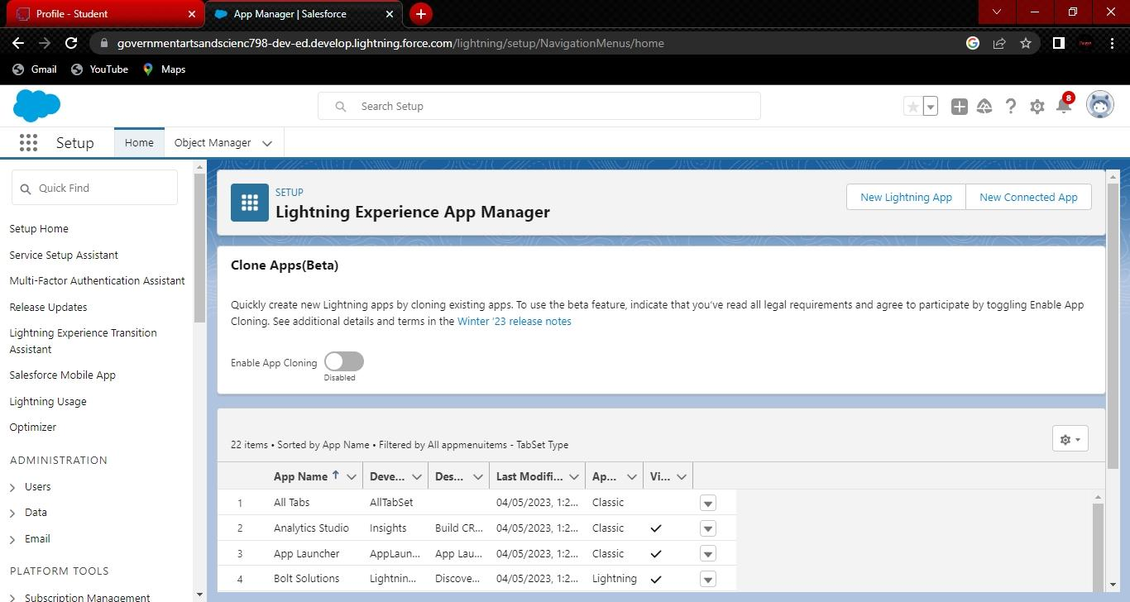

1. And select an option for a new lightning app.
2. Give the app name has sales app.
3. Upload the picture and click next.
4. Choose the app option as navigation style- standard navigation, support from

Factors-desktop & mobile and select next.

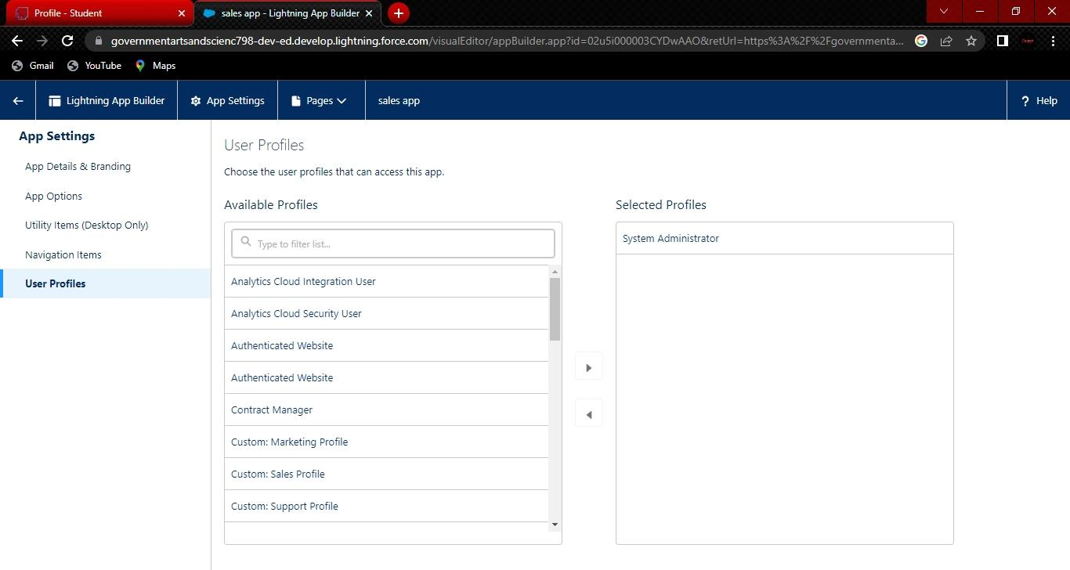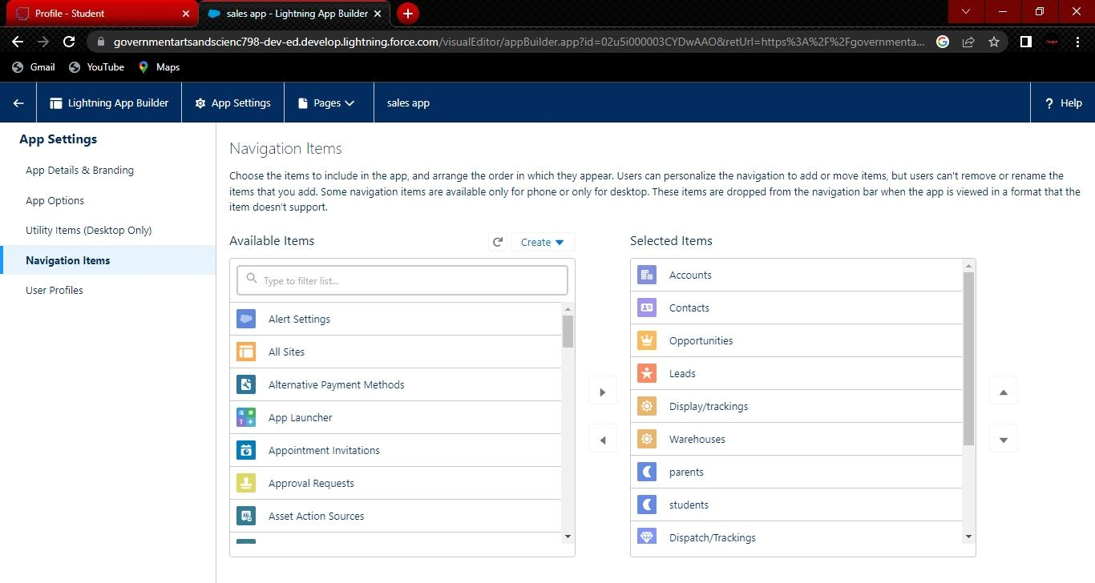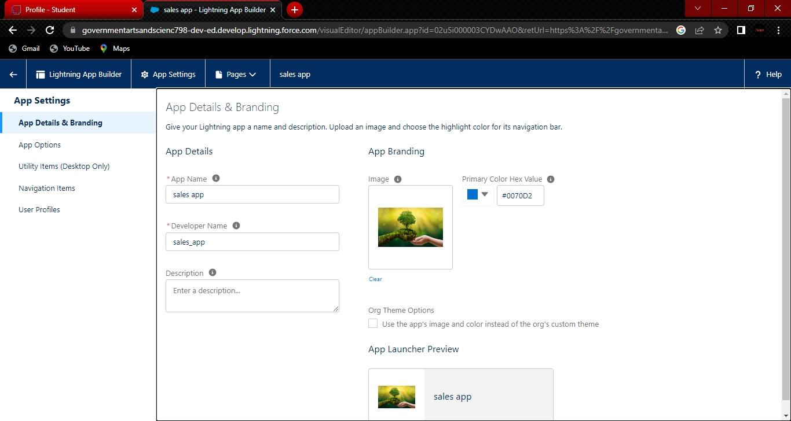

1. And move the objects from available items to selected items.
2. Accounts,contacts,opportunities,Leads,warehouse,dispatch/tracking,campaign to Selected items.
3. And system admin profile to available items to selected items.

**Milestone-5 Layouts:**

Page layouts control the layout of an object, As a crm product owner create custom page layouts Which defines which fields the user can view and edit while entering data in objects. And must Contain different sets of fields and related lists.

Custom Page layouts

1. Warehouse page layout
2. Sales order layout
3. Dispatch/Tracking layout

**Activity-1:**

**Creation of custom Tabs**

1. Now create a custom tab. Click the Home tab, enter Tabs in Quick Find and select Tabs.
2. Under Custom Object Tabs, click New.
3. For Object, select Warehouset.
4. For Tab Style, select any icon.

5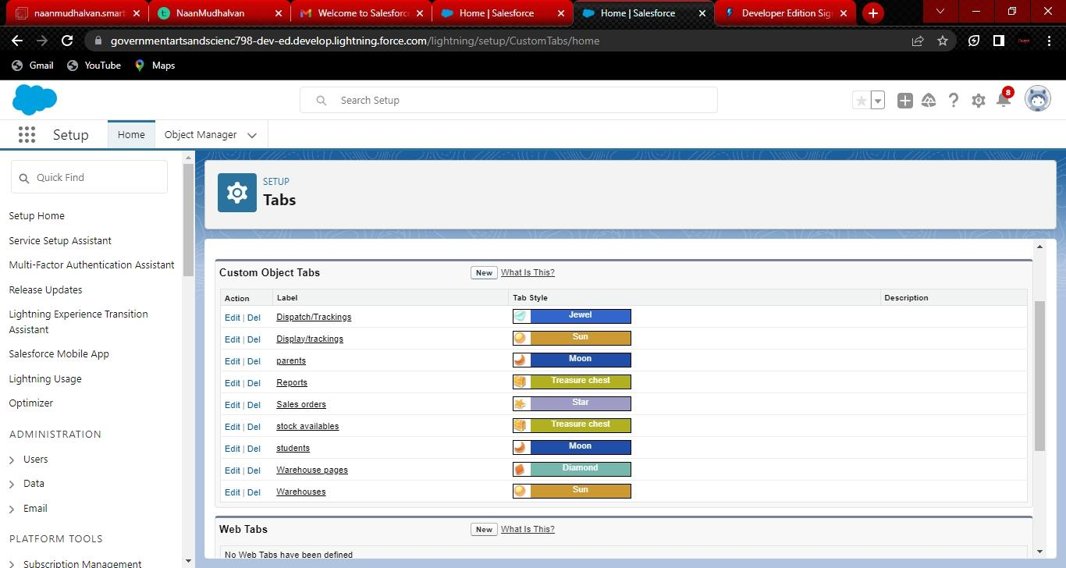) Leave all defaults as is. Click Next, Next, and Save.

6 ) In the same way create other objects such as students and parents.

**Milestone-6 User:**

So what is a user? A user is anyone who logs in to Salesforce. Users are employees at your

Company, such as sales reps, managers, and IT specialists, who need access to the company’s

Records. Every user in Salesforce has a user account

**Activity-1:**

**Creation of user**

1. Navigate to setup in quick find search bar
2. Type user in and select it and click on new user.

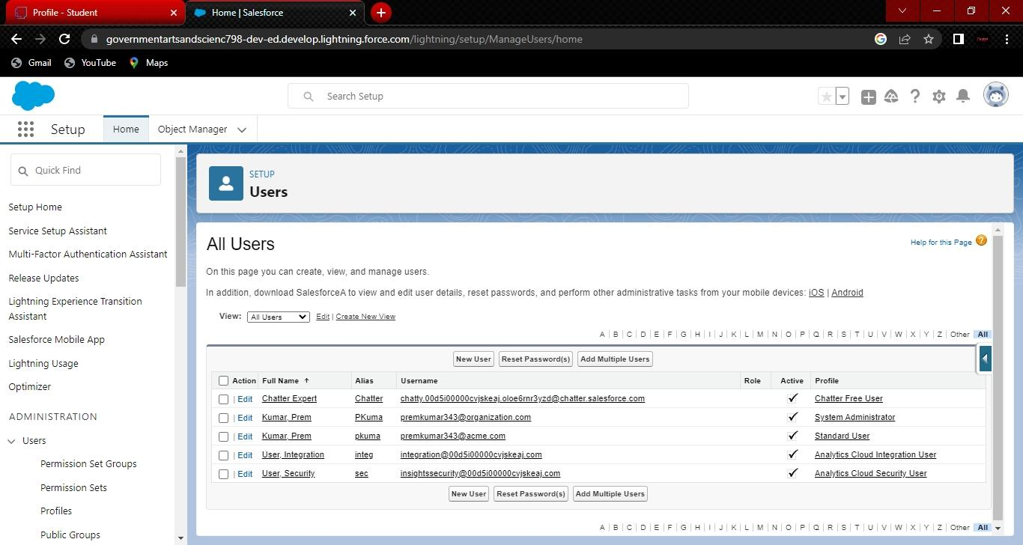

1. Give the first name and last name.
2. Enter your email in the email field.
3. Enter username; it must be unique.
4. Select the user license of salesforce.
5. In the profile field select standard platform profile.

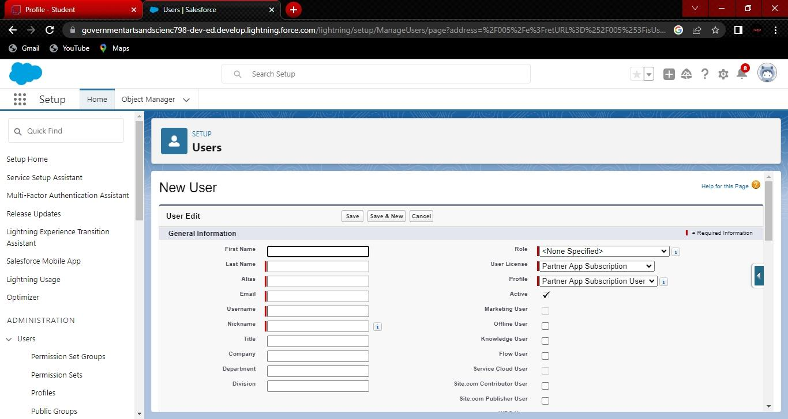

8) At the bottom of the page check the box to generate a new password and notify the user Immediately

**Milestone-7 Validation Rules:**

Validation rules verify that the data a user enters in a record meets the standards you specify Before the user can save the record. As a crm product owner they requested to create a validation Rule on account object on the phone field.

**Activity-1:**

**Creation of validation rule**

1. Navigate to object manager and select Account object.
2. In details section scroll down and find validation rule in it.
3. 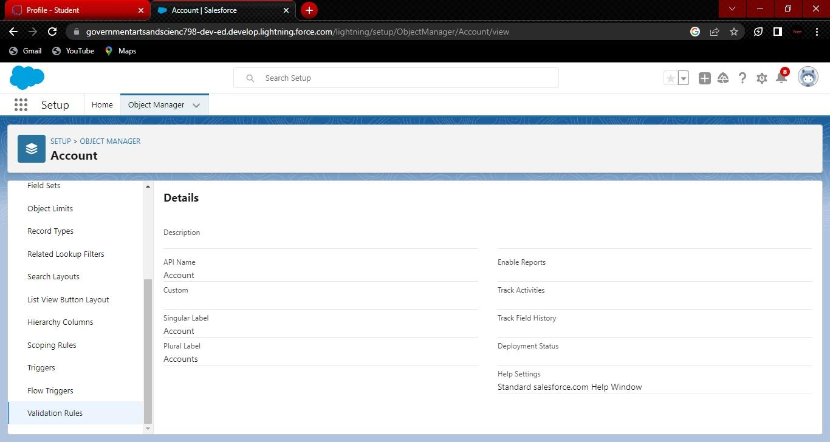Click new, give the label name and in edit error conditional formula give the formula

hasLEFT(Phone, 1) <> “+”.

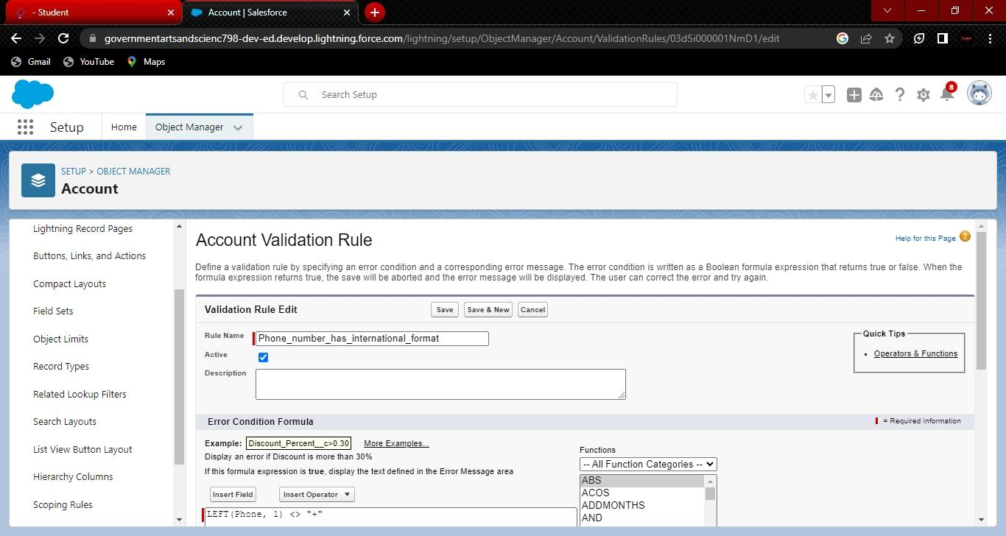

4**)** And in error message give the description has Phone number must begin with + (country

Code).

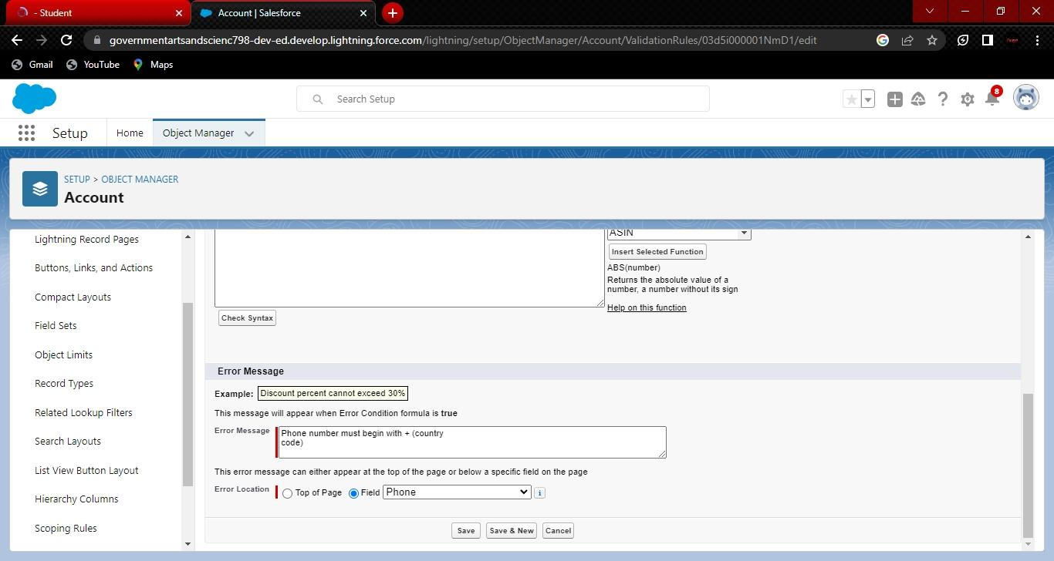 5)In error location select top of the field.

**Activity-2 :**

**Cross Object Formula**

Using an object formula lets you reference merge fields on a master object from a master detail Relationship on the detail object. As a crm product owner they wants to save user’s clicks and Displays contacts’ parent accounts website value on the contact record so users do not have to Click on the account to find the website.

**Creation of cross object**

1. Select your object from object selection has Contact.
2. And select the option fields and relationships.

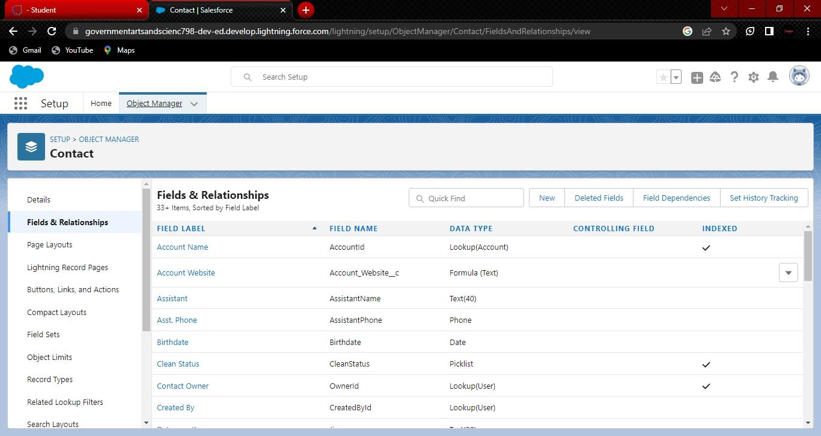

1. At the top right side you can find a new select that option.
2. Now you have to select data type, formula Has data type.

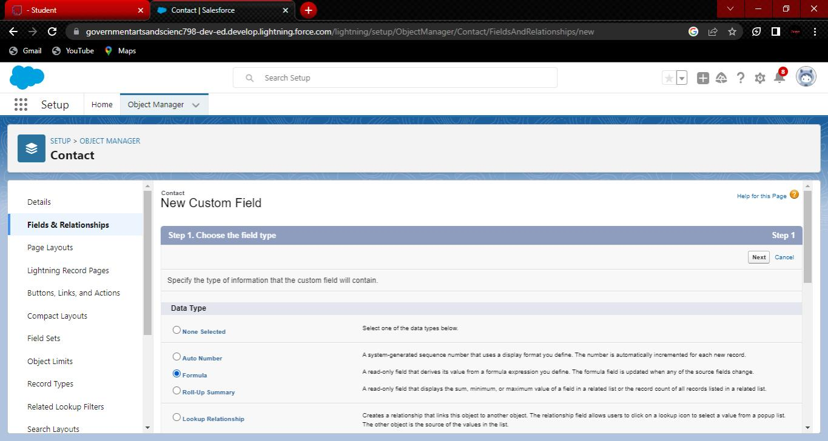

1. And you will navigate to enter the details page where you give the field label.
2. And give the label name has Account Website
3. 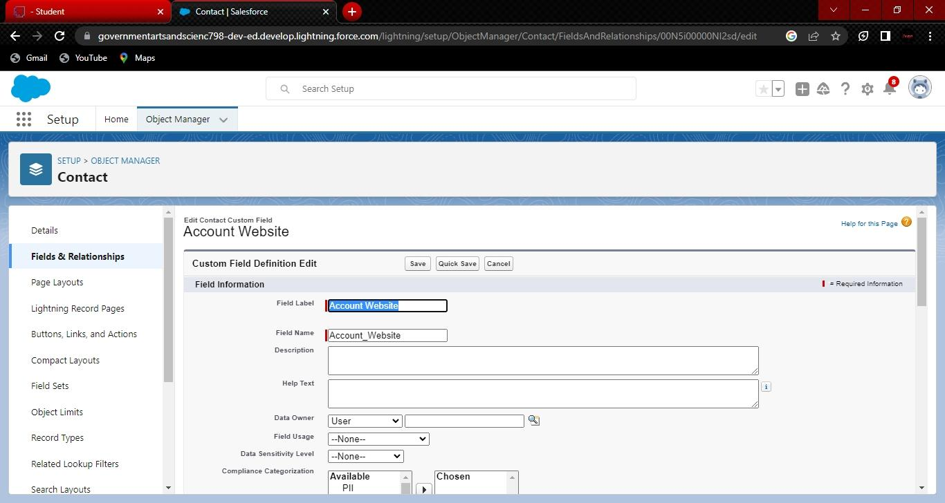In the formula field enter this formula Account.Website.

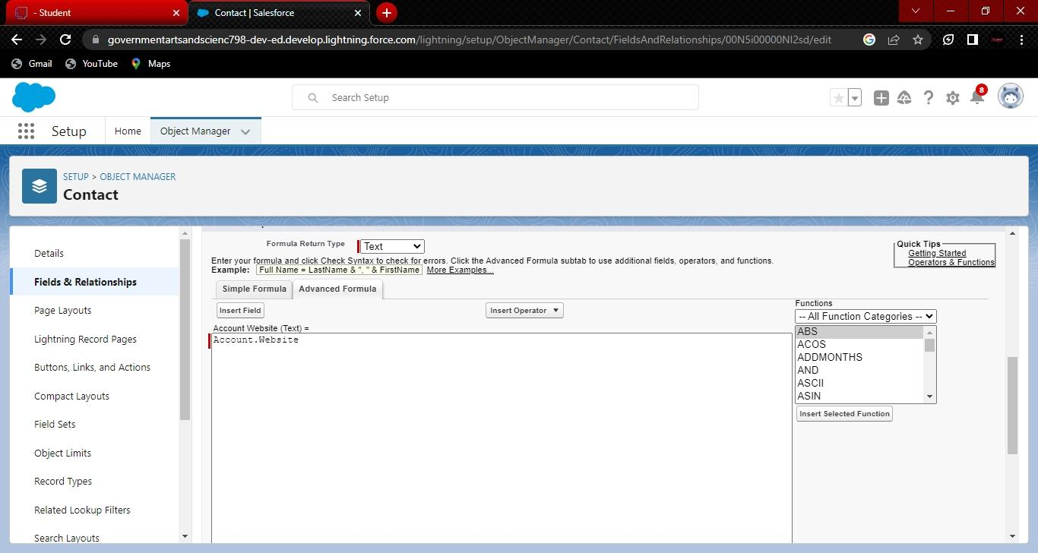

1. At the bottom of the object you can find options like required,unique, external id select Required option so that always require a value in this field in order to save.
2. Click next you will navigate to field level security click on visible checkbox so that it is Visible to all profiles.
3. Select the next option, select the page layout and save it.

**Milestone-7 Reports :**

A report is a list of records that meet the criteria you define. It’s displayed in Salesforce in rows And columns, and can be filtered, grouped, or displayed in a graphical chart. Every report is Stored in a folder. Folders can be public, hidden, or shared, and can be set to read-only or Read/write.

**Activity:**

**Creation of report**

**Note**- While creation of report ensure that update preview automatically is selected which is

Available at the right side of the report page.

1. Click on the app launcher and search for reports.
2. And select a new report, for the record type category select other reports.
3. 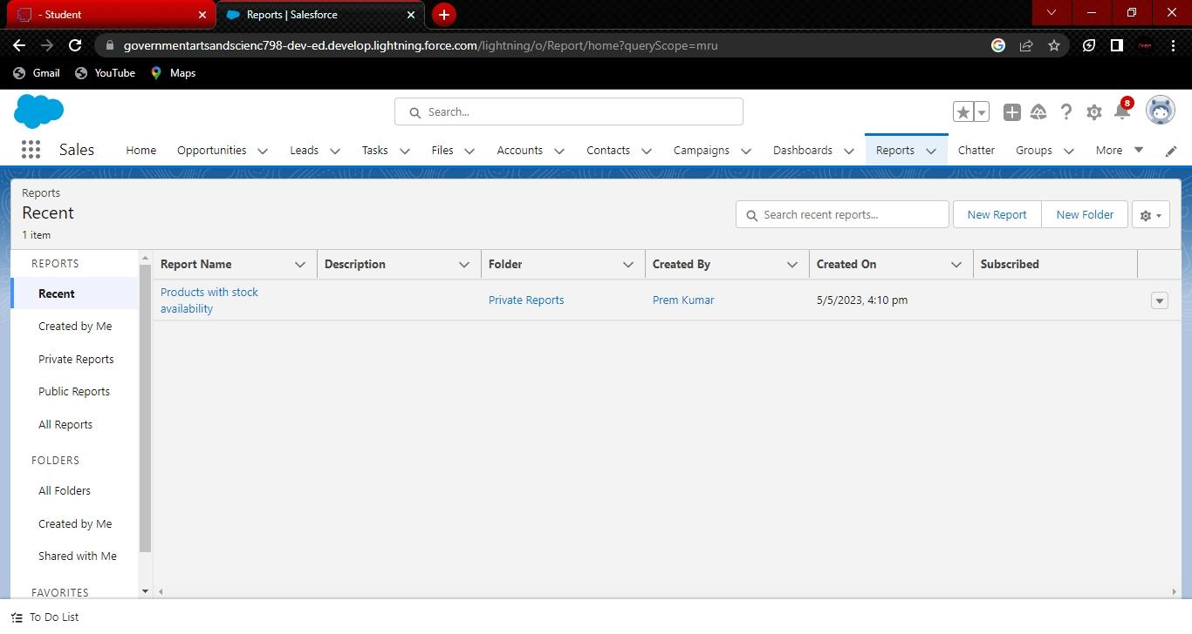Select Warehouses for the report type name.

4 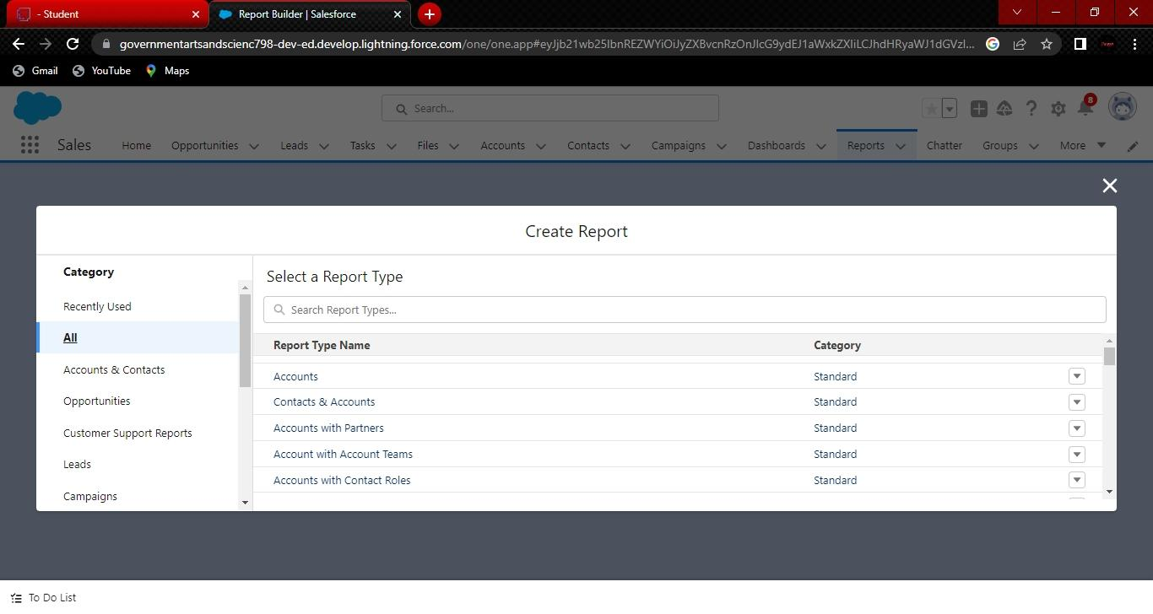) Select the start button to create a new report.

1. 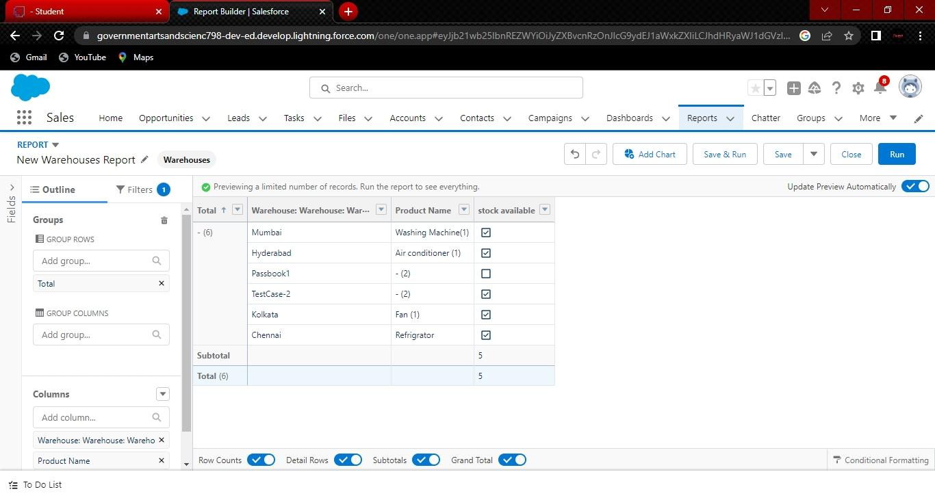At the left side of the report you can find an outline pane.
2. In the group rows select Product name.
3. And in columns warehouse:warehouse name and stock available.
4. Now navigate to the filter pane available next to the outline pane and ensure in the show me section all my warehouses is selected.
5. And in the warehouse created date select all time.

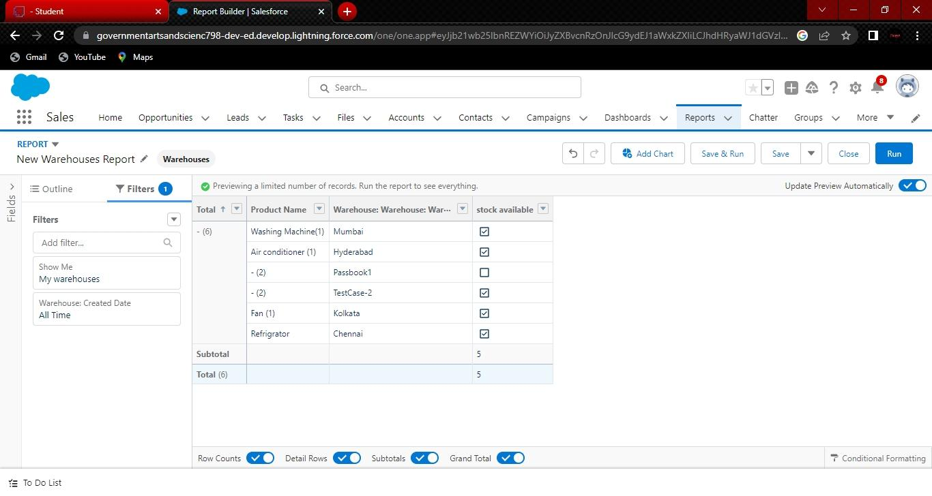

1. And give the label name products with stock availability.

10)Click on save and run for saving the report.

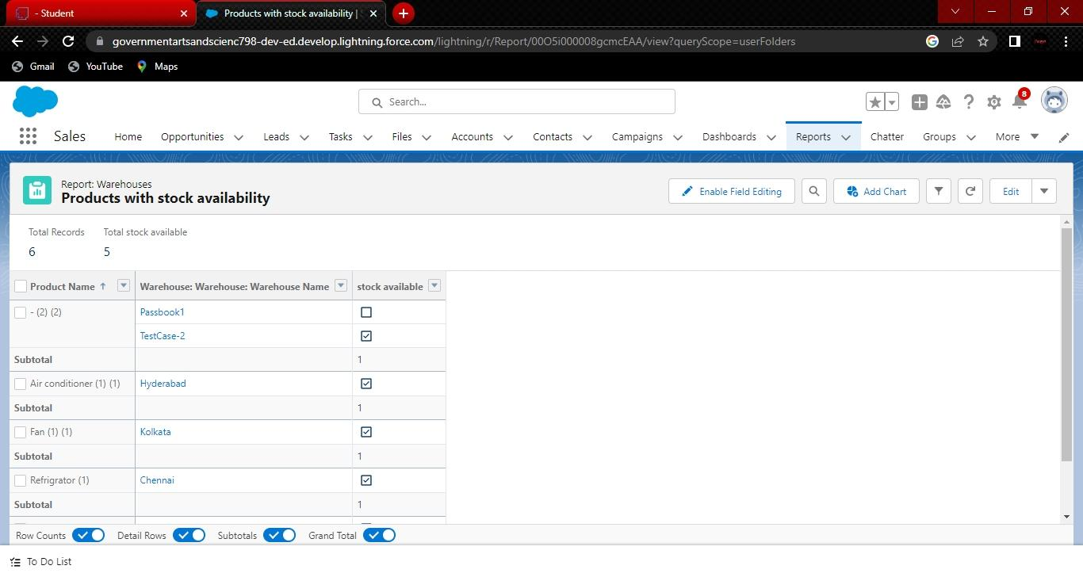

**Milestone-8 Dashboards:**

Dashboards in Salesforce are a graphical representation of Reports. It shows data from source Reports as visual components.

**Activity**

**Creation of Dashboard**

1. Click on the app launcher and search for dashboards.
2. Select the new dashboard option.
3. 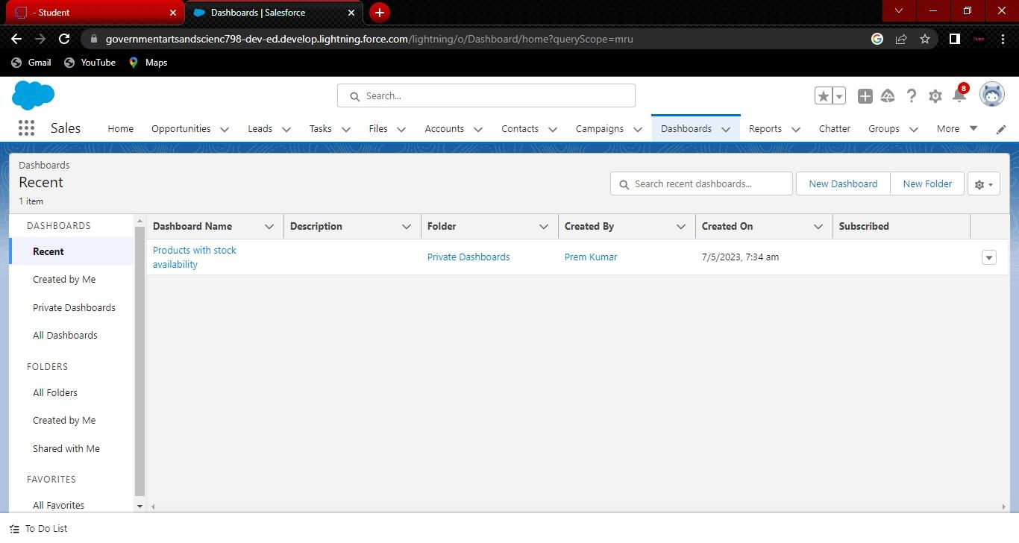Name the dashboard has a products with stock availability.
4. And select create option.
5. Now click on Add component and for report select passport with locations.
6. Select the donut chart in display as section.
7. 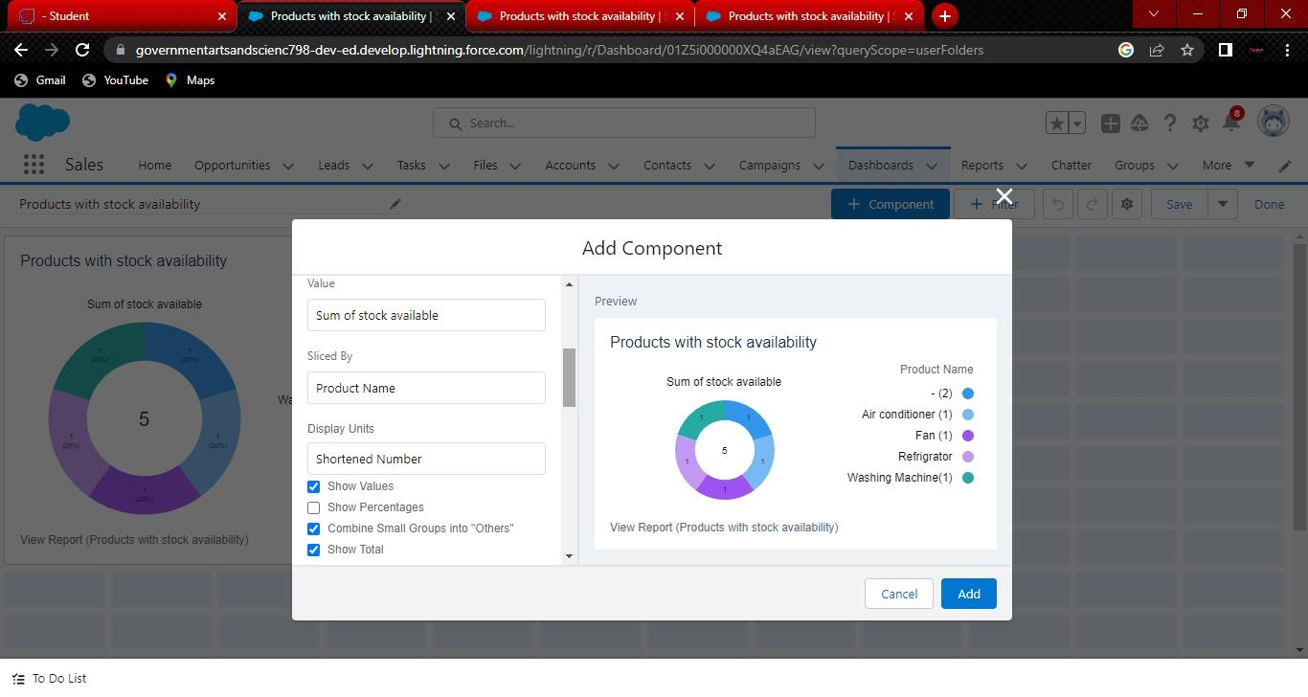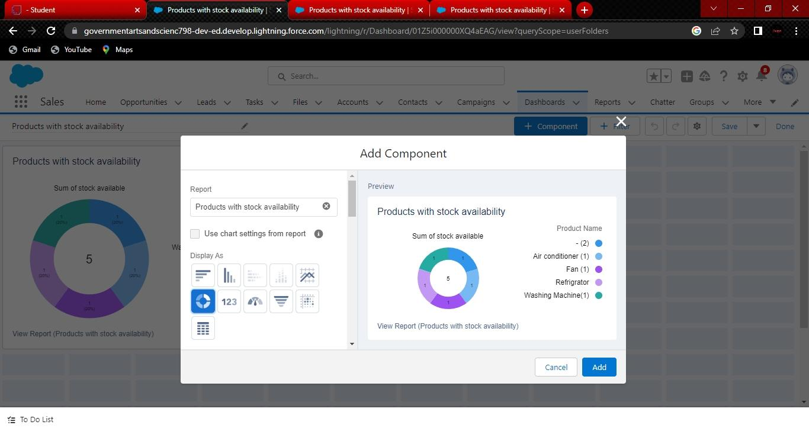Ensure that value is record count and sliced by product name.
8. 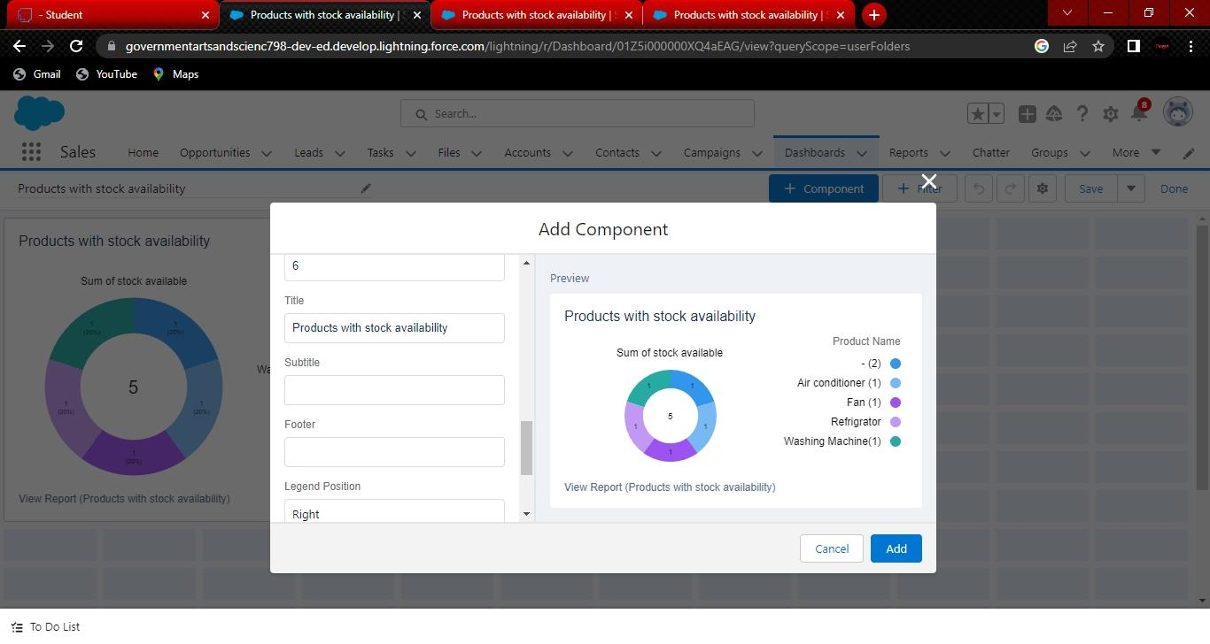Leave the default values.
9. Click on add.

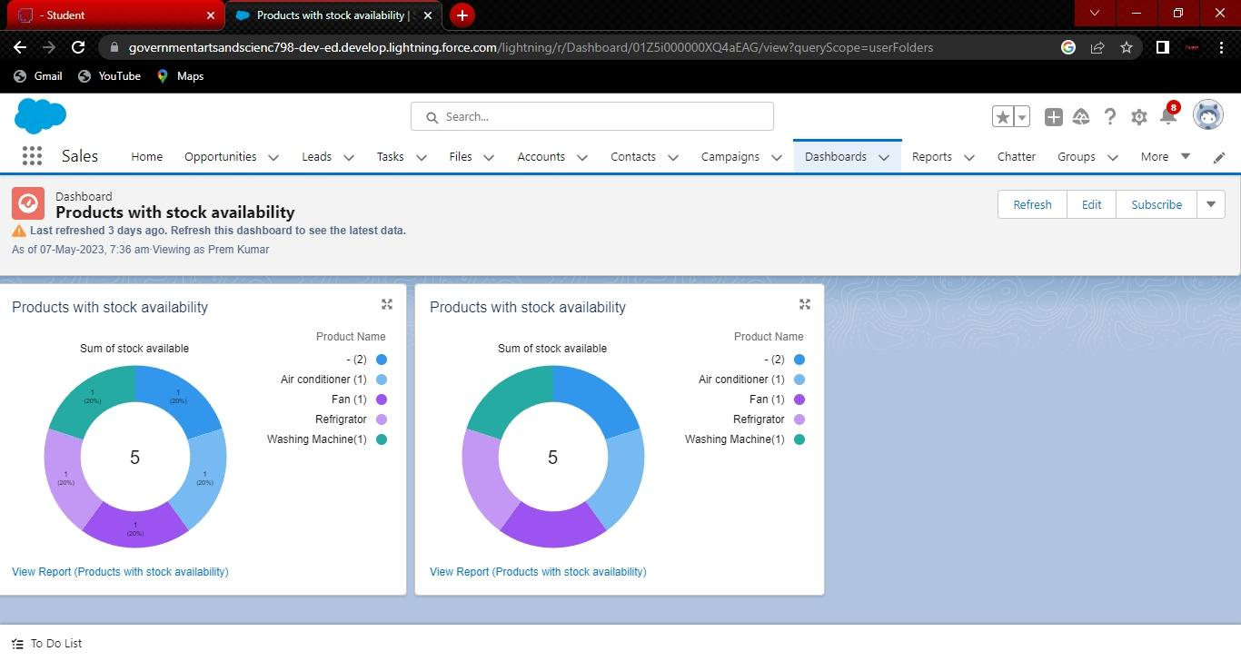10)And save the dashboard.

**TEAM DETAILS**

Team ID : NM2023TMID36571

Team Leader : PREMKUMAR M

Team member : KAVIARASAN S

Team member : KIRTHESH R

Team member : LAKSHMANAN S

**Trailhead Profile Public URL**

Team Lead – <https://trailblazer.me/id/premkumar0m>

Team Member 1 – <https://trailblazer.me/id/kkavi135>

Team Member 2 –<https://trailblazer.me/id/kirthesh77>

Team Member 3 – <https://trailblazer.me/id/lmanan8>

**ADVANTAGES**

Salesforce can be used to manage orders from retail stores and distributors, including tracking orders, processing payments, and managing inventory levels. This can help field sales teams ensure that orders are fulfilled quickly and accurately and that inventory levels are maintained at optimal levels.

**DISADVANTAGE**

1.Expensive.

2.You have to pay for add-ons to get the most out of the software.

3.Configuration and setup is complex and time-consuming.

4.Cluttered interface makes navigation and simple tasks unnecessarily complex.

5.The learning curve never seems to end.

6.Customer support has a poor reputation.

**APPLICATIONS**

Salesforce can be used to manage orders from retail stores and distributors, including tracking orders, processing payments, and managing inventory levels. This can help field sales teams ensure that orders are fulfilled quickly and accurately and that inventory levels are maintained at optimal levels.

**CONCLUSION**

Salesforce can be used to manage orders from retail stores and distributors, including tracking orders, processing payments, and managing inventory levels. This can help field sales teams ensure that orders are fulfilled quickly and accurately and that inventory levels are maintained at optimal levels.

Salesforce for Retail is a set of solutions built on the Salesforce platform designed to help retail companies manage their operations and customer relationships. These solutions include tools for managing inventory, sales, customer data, marketing, and more.

Conclusion. Sales Cloud technologies assist representatives in reducing redundancies, improving procedures, organizing operations, communicating more effectively, and accessing information to complete transactions.

**FUTURE SCOPE**

Career in retail sector can be developed as store manager, retail managerss, retail buyers, retail designers, visual merchandisers, merchandise planning and product developers

Digital technology – such as smart mirrors, digital mannequins, QR codes, interactive apps, and more – will become a staple of physical retail in the future of shopping, allowing brands and retailers to provide guided digital journeys through brick-and-mortar stores

Supervisory, client communication, merchandise shipment, sales, management, and administrative services are all options for candidates with a retail management background. More than 2 million jobs are available in retail management around the world.

**Project login ID**

Salesforce User name- [premkumar343@organization.com](mailto:premkumar343@organization.com)

**Team members Gmail ID.**

**1.** [**mmprem000@gamil.com**](mailto:mmprem000@gamil.com)**.**

**2. subramaniyankavi5@gmail.com**

**3. jkkirthesh@gmail.com**

**4. mananlaksh330@gmail.com**

**Team ID : NM2023TMID36571**



